# CN Assignment 3 Screenshots

**Members:**

1. Muhammad Moaaz bin Sajjad, 20K-0154
2. Saad bin Khalid, 20K-0161

**Screenshots:**

**Normal Working**

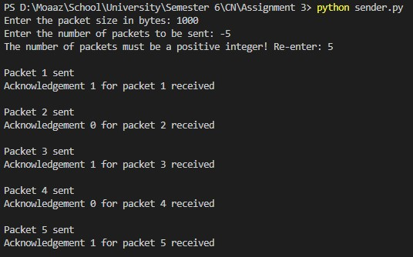

*Sender*

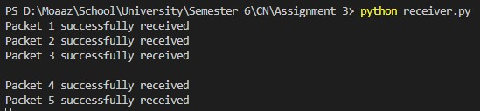

*Receiver*

**Packet Corruption**

Accomplished via changing



on receiving end to:



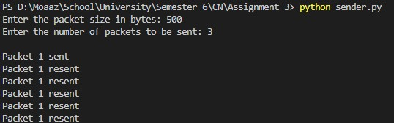

*Sender*

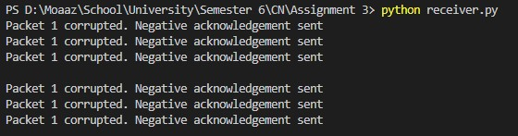

*Receiver*

**Acknowledgement Corruption**

Accomplished via changing



on sending end to:



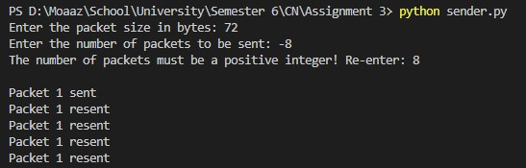

*Sender*

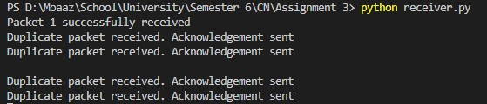

*Receiver*

**Premature Timeout**

Timeout is 3 seconds. To make the timeout premature, a *sleep(5)* statement was added on receiving end.

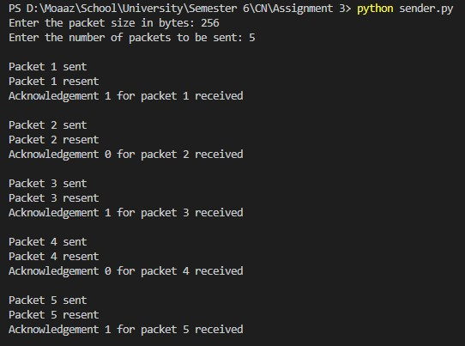

*Sender*

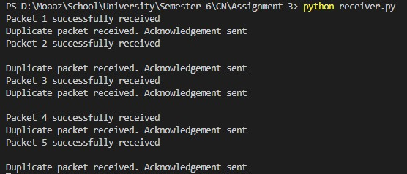

*Receiver*